Terminal commands
Dan Richter
07 Sep 2020

Let’s start taking a look at some of the terminal commands used in Linux. If you are familiar with some of the dos/Windows commands, I will reference their counterparts for each of them.

Navigating the file system

pwd

pwd stands for Print Work Directory. It does exactly what you think it would do, it tells you where you are in the file system.
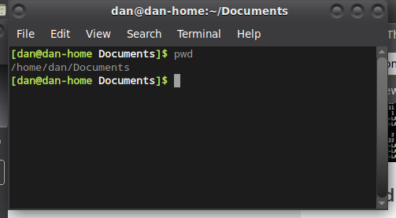

ls

If you have ever used the ‘dir’ command in dos/Windows, this is the Linux equivalent. It will give you the contents of the directory that you are in.

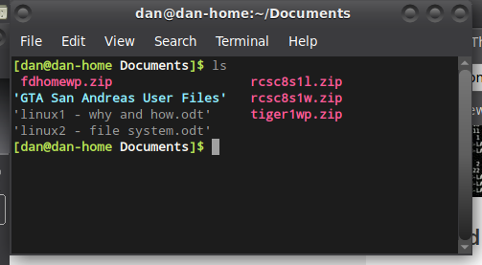
cd

This works exactly the same as the ‘cd’ command in dos/Windows. It allows you to change from one directory to another. In the following example, the ‘cd’ command was used to go back (up) to the previous directory. In this case, from Downloads to Home.
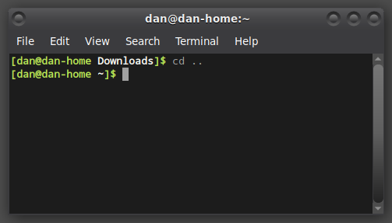
As ‘cd’ is one of the most used commands, I wanted to give you a little more information about it. First of all, there are some shortcuts that can be used. One of which, I used in the previous example. Instead of typing ‘cd /home/dan’ to go back to the home directory, I typed in ‘cd ..’ which will take you back one directory, in this case from /home/dan/Documents to /home/dan. Another way this could be done is to use the ‘~’ key. This represents your /home directory. So, I could have typed ‘cd ~’ and would have been taken to the home directory as well. Or, I could have typed in ‘cd’ by itself, and Linux would take me back to the home directory. All of these are very useful and quick ways to move around in the Linux file system.

mkdir

This command is used for creating a new directory. It is similar to the ‘md’ command in dos/Windows. As you can see if the following example, the temp2 directory did not contain anything. After running the ‘mkdir temp’, there was a sub-directory called temp inside of the directory.

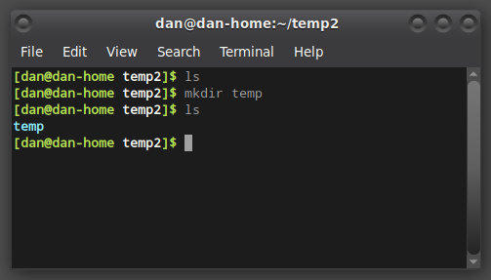
rmdir

This is the opposite of the last command, as it will remove a directory from the command line. This time, in the example, you can see the ‘temp’ sub-directory was there, and after running the ‘rmdir temp’ command, it was removed.

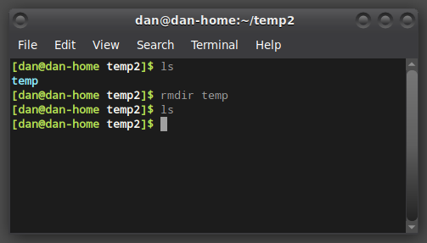
lsblk

If you need to look and see a list of the block devices on your system, you can use this ‘lsblk’ command. In this example, it shows a tree structure of the block devices on my system.

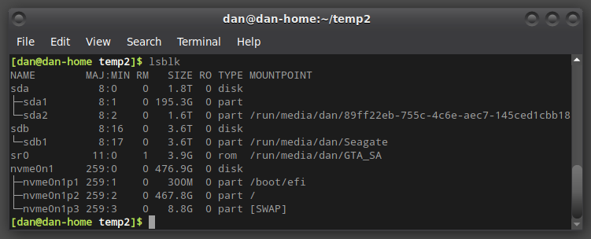
mount

If you need to manually mount a drive in Linux, the ‘mount’ command is used.

df

This is one of the most important commands that can be used in the terminal. This will show you the available space on each of the drives mounted on your system.
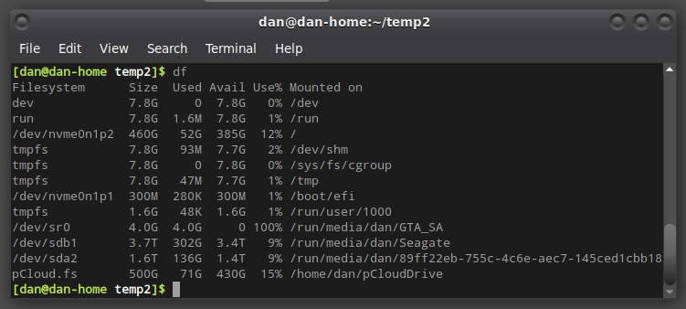

As this is already getting a bit lengthy, I’ll stop here. In the next update, we’ll take a look at some more commands that will give you a lot of power on a Linux system.

